The Great Entertainment Page
1

Hello, my name is Sam and I am a student at Pedare Christian College in Adelaide, Australia. As part of a project I wanted to reach out to people and the community to create something that offers both a challenge, and relaxation during these uncertain times. Get thinking and try to solve it!
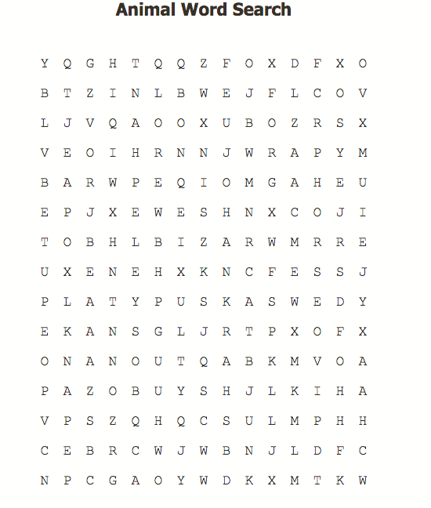
Which number is needed to complete the pyramid?
_______

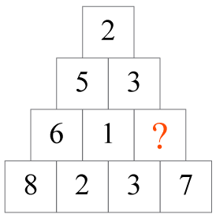

C | I | R
C | H | E
L | O | N
NINE LETTER WORD
Can you solve it?
How many words can you find?

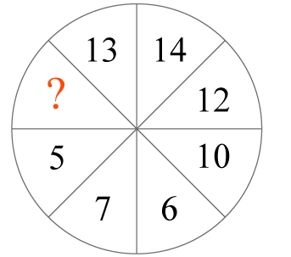

CHIMPANZEE | ELEPHANT | FOX
GOOSE | HORSE | KANGAROO
PLATYPUS | RHINO | SHARK

What is the missing 1-digit number?
____________

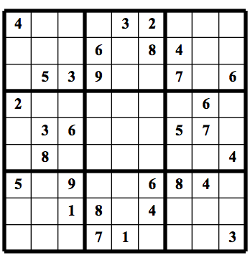
SOLVE IT!
Three playing cards in a row. Can you name them with these clues? There is a two to the right of a king. A diamond will be found to the left of a spade. An ace is to the left of a heart. A heart is to the left of a spade. Now, identify all three cards.
What has six faces, but does not wear makeup, has twenty-one eyes, but cannot see? What is it?

Ans) Ace of Diamonds, King of Hearts, Two of Spades Ans) A dice Pyramid Ans) 4 Missing number Ans) 3

The Great Entertainment Page
2

Hello, my name is Sam and I am a student at Pedare Christian College in Adelaide, Australia. As part of a project I wanted to reach out to people and the community to create something that offers both a challenge, and relaxation during these uncertain times. Get thinking and try to solve it!
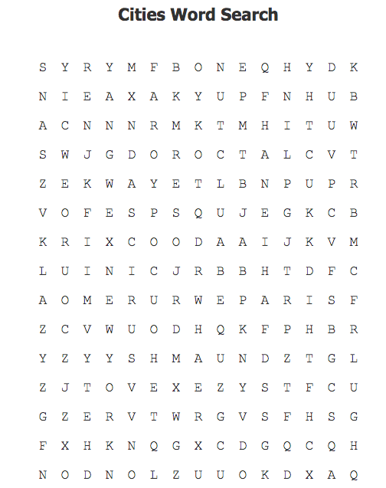
E | I | E
T | I | Q
U | X | S
NINE LETTER WORD
Can you solve it?
How many words can you get?
I am a word of six; my first three letters refer to an automobile; my last three letters refer to a household animal; my first four letters is a fish; my whole is found in your room. What am I?

As a stone inside a tree, I’ll help your words outlive thee. But if you push me as I stand, the more I move the less I am. What am I?
I have cities but no houses, forests but no trees, water but no fish.

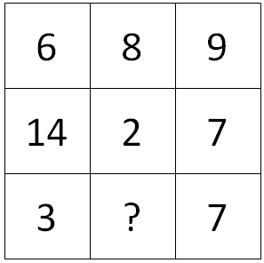

Find the Missing Number!!!
Your parents have six sons including you and each son has one sister.
How many people are in the family?

____________________________________

BANGKOK | DUBAI | LONDON
NEWYORK | PARIS | ROME
SINGAPORE | SYDNEY | TOKYO

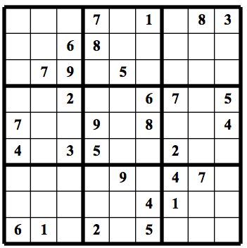
Ans) A carpet Ans) A pencil Ans) A map
Ans) Two parents, Six Sons and One Daughter
Ans) The missing Number is 13

oi
The Great Entertainment Page
36

Hello, my name is Sam and I am a student at Pedare Christian College in Adelaide, Australia. As part of a project I wanted to reach out to people and the community to create something that offers both a challenge, and relaxation during these uncertain times. Get thinking and try to solve it!
Ans) There aren’t any—it’s a one-story house Ans) A piano Ans) All the people on the boat are married. Ans) A river Ans) 96000 Ans) The man’s son

What Does 30 equal?
______
7 = 4149
12 = 12444
25 = 65025
33= 166089
15 = 23025
30 = ? ? ?

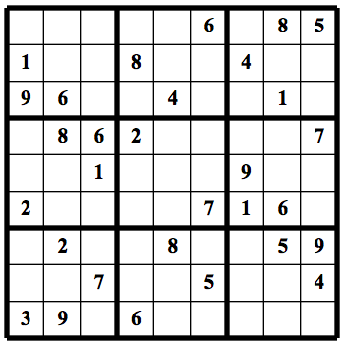
There’s a one-story house in which everything is yellow. Yellow walls, yellow doors, yellow furniture. What colour are the stairs?

You see a boat filled with people, yet there isn’t a single person on board. How is that possible?

What has many keys but can’t open a single lock?

What can run but never walks, has a mouth but never talks, has a head but never weeps, has a bed but never sleeps?

A man looks at a painting in a museum and says, “Brothers and sisters I have none, but that man’s father is my father’s son.” Who is in the painting?

S | I | E
E | M | S
H | A | P

NINE LETTER WORD
Can you solve it?
How many words can you get?

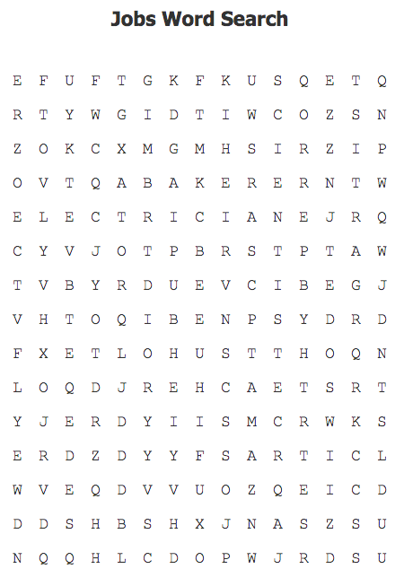
ACTOR | ARTIST | BAKER
BUILDER | CARPENTER | DOCTOR
ELECTRICIAN | SCIENTIST | TEACHER

